Regression: It is a tool/Predictive Modelling technique for finding the relationship between a Explained variables (dependent/Target) and one or more explanatory variables (independent/Predictor) in a study.

This technique is used for forecasting, time series modelling and finding the causal effect relationship between the variables.

For example, relationship between rash driving and number of road accidents by a driver is best studied through regression.
Benefits of using regression analysis.
- It indicates the significant relationships between dependent variable and independent variable.
- It indicates the strength of impact of multiple independent variables on a dependent variable.
Regression techniques are mostly driven by three metrics (number of independent variables, type of dependent variables and shape of regression line).
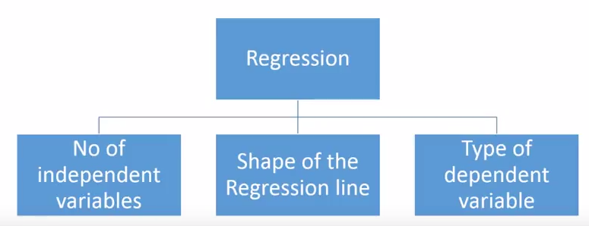

- The relationship can be linear or non linear
- The basic function of regression is to identify statistically significant explanatory variables and estimate the model parameters.

Difference between Correlation and regression:
- Correlation is measuring the association and direction between the variables. Correlation quantifies the degree to which two variables are related .Regression describes how an independent variable is numerically related to the dependent variable.
- Correlation is to represent linear relationship between two variables while regression is to fit a best line and estimate one variable on the basis of another variable.
- Correlation coefficient indicates the extent to which two variables move together while Regression indicates the impact of a unit change in the known variable (x) on the estimated variable (y).
- Correlation aims at finding a numerical value that expresses the relationship between variables. Unlike regression whose goal is to predict values of the random variable on the basis of the values of fixed variable.
Scatterplot is used to analyze correlation

Linear Regression:
Linear Regression establishes a relationship between dependent variable (Y) and one or more independent variables (X) using a best fit straight line (also known as regression line).
It is represented by an equation Y= a+ b*X + e, where a is intercept, b is slope of the line/ Coefficient of Determination and e is error term, X is the value of the independent variable, and Y is the predicted value of the dependent variable. This equation can be used to predict the value of target variable based on given predictor variable(s).
Simple Linear Regression is used when we have, one independent variable and one dependent variable. The simplest form of regression with one dependent and one independent variable is defined by the formula:
Y= a+ b*X
Here, we establish relationship between independent and dependent variables by fitting a best line. This best fit line is known as regression line and represented by a linear equation Y= a+ b*X
When to use this technique?
In this technique, the dependent variable is continuous, independent variable(s) can be continuous or discrete, and nature of regression line is linear.

How to find the best regression line?
Best fit line tends to return most accurate value of Y based on X i.e. causing a minimum difference between actual and predicted value of Y (lower prediction error).
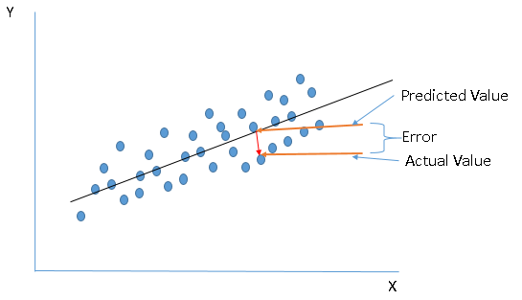
Here are some methods which check for error:
- Sum of all errors (∑error)
- Sum of absolute value of all errors (∑|error|)
- Sum of square of all errors (∑error^2)
Coefficients a and b are derived based on minimizing the sum of squared difference of distance between data points and regression line.
There are two common algorithms to find the right coefficients for minimum sum of squared errors, first one is Ordinary Least Square (OLS) and other one is gradient descent.

What are the performance evaluation metrics in Regression?
- Minimum sum of squared errors (SSE)
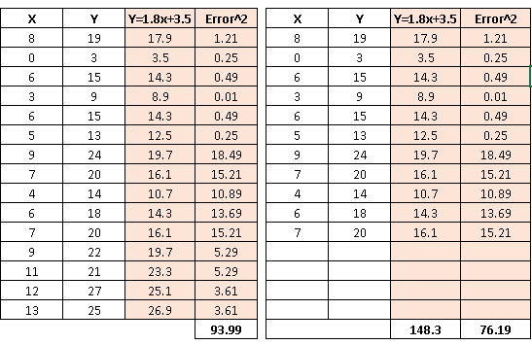
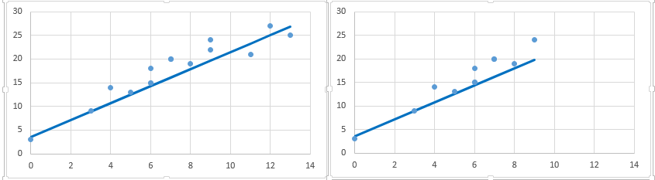
We have removed 4 data points in right table and therefore the SSE has reduced (with same regression line). Further, if you look at the scatter plot, removed data points have almost similar relationship between x and y. It means that SSE is highly sensitive to number of data points.
- R-square (Coefficient of variation/Goodness of Fit) and most common metric to judge the performance of regression models. R² measures, “How much the change in output variable (y) is explained by the change in input variable(x). R2 is used to determine how closely a regression model "fits" or explains the relationship between the independent variable (X) and the dependent variable (Y). Closer R2 is to 1, the better the regression model explains the observed data.
R² of 0.10 means that 10 percent of the variance in Y is predictable from X; an R² of 0.20 means that 20 percent is predictable; and so on.
R-squared is always between 0 and 1:
- 0 indicates that the model explains NIL variability in the response data around its mean.
- 1 indicates that the model explains full variability in the response data around its mean.
In general, higher the R², more robust will be the model.
- High R² may not always mean good model!!
  - Residual issue
- Low R² may be better model!!
  - Add more predictors, interaction terms
- Decision of goodness of fit is not solely determined by R²
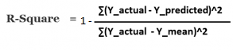
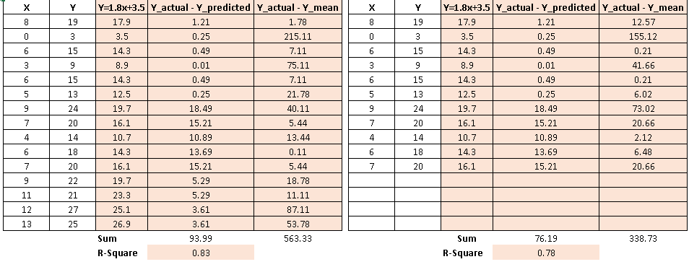
As you can see, R² has less variation in score compare to SSE.
R²= Explained Variance / Total Variance
Adjusted R square : When we introduce new explanatory variable in the equation then R square will increases. Adjusted R square will tell whether the new explanatory variable that is introduced will be statistically significant or not. It will take care of adjustment in the coefficient of determination.
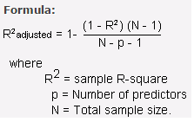
Adjusted R-squared should always be used with models with more than one predictor variable. It is interpreted as the proportion of total variance that is explained by the model.
F statistic : F statistic tests whether the predictor variables taken together, predict the response variable above chance levels(p value)
Residuals: The difference between the observed value of the dependent variable (y) and the predicted value (ŷ) is called the residual (e). Each data point has one residual.
Residual = Observed value - Predicted value
e = y - ŷ
Both the sum and the mean of the residuals are equal to zero. That is, Σ e = 0 and e = 0.

Residual Plots

A residual plot is a graph that shows the residuals on the vertical axis and the independent variable on the horizontal axis. If the points in a residual plot are randomly dispersed around the horizontal axis, a linear regression model is appropriate for the data; otherwise, a non-linear model is more appropriate.

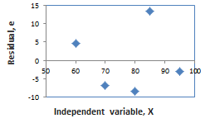
The sum of the residuals is always zero, whether the data set is linear or nonlinear.
Below, the residual plots show three typical patterns. The first plot shows a random pattern, indicating a good fit for a linear model. The other plot patterns are non-random (U-shaped and inverted U), suggesting a better fit for a non-linear model.
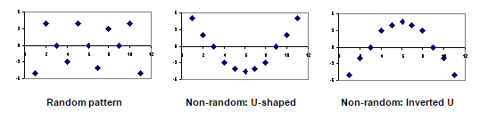
Residual Plot - Introduction
Residual plot is a plot of error (or standardized error) against one of the following variables:
- The dependent variable Y.
- The independent variable X.
- The standardized independent or dependent variable.
if the residuals do not follow normal distribution?
T Test is not valid
F Test is not valid
Reasons why we should use Residual Analysis.
- Analysis of residuals reveal whether the assumption of normally distributed errors hold.
- Residual plots are used to check if there is heteroscedasticity problem (non constant variance for the error term).
- Residual analysis could also indicate if there are any missing variables.
- Residual plot can also reveal if the actual relationship is non-linear.

Check the normality of error terms
- Probability plot is a graphical technique for checking whether or not a data set follows a given distribution.
- The data is plotted against a theoretical distribution in such a way that the points should form a straight line.
- In Regression, we create a probability plot of error against normal distribution.
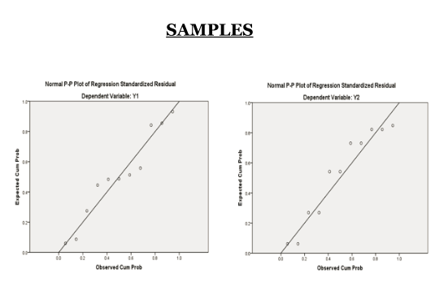

Check for heteroscedasticity
- A graph of the residuals versus independent variable Y or dependent variable X will reveal whether the variance of the errors are constant.
- If the width of the scatter plot of the residuals either increases or decreases as X (or Y) increases, then the assumption of constant variance is not met.
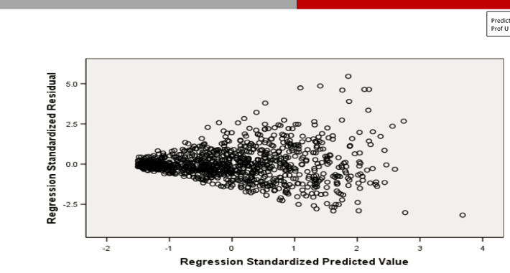
Check for non-linearity
- If the residual plot exhibits a curve when plotted, then the actual relationship is non-linear.
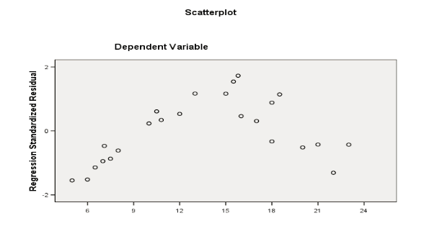
How to "transform" the data to use a linear model with nonlinear data?
Transforming a variable involves using a mathematical operation to change its measurement scale.
- Linear transformation. A linear transformation preserves linear relationships between variables. Therefore, the correlation between x and y would be unchanged after a linear transformation. Examples of a linear transformation to variable x would be multiplying x by a constant, dividing x by a constant, or adding a constant to x.
- Nonlinear transformation. A nonlinear transformation changes (increases or decreases) linear relationships between variables and, thus, changes the correlation between variables. Examples of a nonlinear transformation of variable x would be taking the square root of x or the reciprocal of x.
In regression, a transformation to achieve linearity is a special kind of nonlinear transformation. It is a nonlinear transformation that increases the linear relationship between two variables.

Methods of Transforming Variables to Achieve Linearity

There are many ways to transform variables to achieve linearity for regression analysis. Some common methods are summarized below.
Method | Transformation(s) | Regression equation | Predicted value (ŷ)
Standard linear regression | None | y = b₀ + b₁x | ŷ = b₀ + b₁x
Exponential model | Dependent variable = log(y) | log(y) = b₀ + b₁x | ŷ = 10^{b}₀ ^{+ b}₁^{x}
Quadratic model | Dependent variable = sqrt(y) | sqrt(y) = b₀ + b₁x | ŷ = ( b₀ + b₁x )²
Reciprocal model | Dependent variable = 1/y | 1/y = b₀ + b₁x | ŷ = 1 / ( b₀ + b₁x )
Logarithmic model | Independent variable = log(x) | y= b₀ + b₁log(x) | ŷ = b₀ + b₁log(x)
Power model | Dependent variable = log(y)  Independent variable = log(x) | log(y)= b₀ + b₁log(x) | ŷ = 10^{b}₀ ^{+ b}₁^{log(x)}

How to Perform a Transformation to Achieve Linearity
- Transforming a data set to enhance linearity is a multi-step, trial-and-error process.
- Conduct a standard regression analysis on the raw data.
- Construct a residual plot.
  - If the plot pattern is random, do not transform data.
  - If the plot pattern is not random, continue.
- Compute the coefficient of determination (R²).
- Choose a transformation method (see above table).
- Transform the independent variable, dependent variable, or both.
- Conduct a regression analysis, using the transformed variables.
- Compute the coefficient of determination (R²), based on the transformed variables.
  - If the transformed R² is greater than the raw-score R², the transformation was successful. Congratulations!
  - If not, try a different transformation method.

Multiple Linear Regression: When there is more than one predictor/Independent variable then simple Linear Regression becomes Multiple Linear Regression
In a multiple regression model, we try to predict
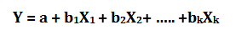
Here, b1, b2, b3 …bk are slopes for each independent variables X1, X2, X3….Xk and a is intercept.
Several Independent variables may influence the response variable we are trying to study
Once you have identified the level of significance between independent variables(IV) and dependent variables(DV), use these significant IVs to make more powerful and accurate predictions. This technique is known as “Multi-variate Regression”.

Important Points:
- There must be linear relationship between independent and dependent variables
- Multiple regression suffers from Multicollinearity, Autocorrelation, Heteroskedasticity.
- Linear Regression is very sensitive to Outliers. It can terribly affect the regression line and eventually the forecasted values.
- Multicollinearity can increase the variance of the coefficient estimates and make the estimates very sensitive to minor changes in the model. The result is that the coefficient estimates are unstable
- In case of multiple independent variables, we can go with forward selection, backward elimination and step wise approach for selection of most significant independent variables.
Assumptions in Regression:
- There should be a linear and additive relationship between dependent (response) variable and independent (predictor) variable(s). A linear relationship suggests that a change in response Y due to one unit change in X¹ is constant, regardless of the value of X¹. An additive relationship suggests that the effect of X¹ on Y is independent of other variables.
- There should be no correlation between the residual (error) terms. Absence of this phenomenon is known as Autocorrelation.
This is valid when were are talking about a time series data.
- The independent variables should not be correlated. Absence of this phenomenon is known as Multicollinearity.
- The error terms must have constant variance. This phenomenon is known as Homoskedasticity. The presence of non-constant variance is referred to Heteroskedasticity.
- The error terms/ Residual terms must be normally distributed.
- The dependent and independent variables should follow normal distribution
- The error terms are not correlated to any of the independent variables

What if these assumptions get violated ?
Let’s dive into specific assumptions and learn about their outcomes (if violated):
1. Linear and Additive: If you fit a linear model to a non-linear, non-additive data set, the regression algorithm would fail to capture the trend mathematically, thus resulting in an inefficient model. Also, this will result in erroneous predictions on an unseen data set.
How to check: Look for residual vs fitted value plots (explained below). Also, you can include polynomial terms (X, X², X³) in your model to capture the non-linear effect.
2. Autocorrelation: The presence of correlation in error terms drastically reduces model’s accuracy. This usually occurs in time series models where the next instant is dependent on previous instant. If the error terms are correlated, the estimated standard errors tend to underestimate the true standard error.
If this happens, it causes confidence intervals and prediction intervals to be narrower. Narrower confidence interval means that a 95% confidence interval would have lesser probability than 0.95 that it would contain the actual value of coefficients. Let’s understand narrow prediction intervals with an example:
For example, the least square coefficient of X¹ is 15.02 and its standard error is 2.08 (without autocorrelation). But in presence of autocorrelation, the standard error reduces to 1.20. As a result, the prediction interval narrows down to (13.82, 16.22) from (12.94, 17.10).
Also, lower standard errors would cause the associated p-values to be lower than actual. This will make us incorrectly conclude a parameter to be statistically significant.
How to check: Look for Durbin – Watson (DW) statistic. It must lie between 0 and 4. If DW = 2, implies no autocorrelation, 0 < DW < 2 implies positive autocorrelation while 2 < DW < 4 indicates negative autocorrelation. Also, you can see residual vs time plot and look for the seasonal or correlated pattern in residual values.
3. Multicollinearity: This phenomenon exists when the independent variables are found to be moderately or highly correlated. In a model with correlated variables, it becomes a tough task to figure out the true relationship of a predictors with response variable. In other words, it becomes difficult to find out which variable is actually contributing to predict the response variable.
Another point, with presence of correlated predictors, the standard errors tend to increase. And, with large standard errors, the confidence interval becomes wider leading to less precise estimates of slope parameters.
Also, when predictors are correlated, the estimated regression coefficient of a correlated variable depends on which other predictors are available in the model. If this happens, you’ll end up with an incorrect conclusion that a variable strongly / weakly affects target variable. Since, even if you drop one correlated variable from the model, its estimated regression coefficients would change. That’s not good!
How to check: You can use scatter plot to visualize correlation effect among variables. Also, you can also use VIF factor. VIF value <= 4 suggests no multicollinearity whereas a value of >= 10 implies serious multicollinearity. Above all, a correlation table should also solve the purpose.
4. Heteroskedasticity: The presence of non-constant variance in the error terms results in heteroskedasticity. Generally, non-constant variance arises in presence of outliers or extreme leverage values. Look like, these values get too much weight, thereby disproportionately influences the model’s performance. When this phenomenon occurs, the confidence interval for out of sample prediction tends to be unrealistically wide or narrow.
How to check: You can look at residual vs fitted values plot. If heteroskedasticity exists, the plot would exhibit a funnel shape pattern (shown in next section). Also, you can use Breusch-Pagan / Cook – Weisberg test or White general test to detect this phenomenon.
5. Normal Distribution of error terms: If the error terms are non- normally distributed, confidence intervals may become too wide or narrow. Once confidence interval becomes unstable, it leads to difficulty in estimating coefficients based on minimization of least squares. Presence of non – normal distribution suggests that there are a few unusual data points which must be studied closely to make a better model.
But, if it is not a normal distribution, some of those hypotheses tests which we will be doing as part of diagnostics may not be valid. For example, to check whether the Beta is significant or not, or the regression coefficient is significant or not, I'll do a T-test. So, if my error is not a normal distribution, then the statistic I derive may not be a T-distribution. So, my diagnostic test or hypotheses test is not valid.
How to check: You can look at QQ plot (shown below). You can also perform statistical tests of normality such as Kolmogorov-Smirnov test, Shapiro-Wilk test.
What is Multicollinearity?
Multicollinearity exists whenever two or more of the predictors/Independent variables in a regression model are moderately or highly correlated.
Types of Multicollinearity
- Structural multicollinearity is a mathematical artifact caused by creating new predictors from other predictors — such as, creating the predictor x² from the predictor x.
- Data-based multicollinearity, on the other hand, is a result of a poorly designed experiment, reliance on purely observational data, or the inability to manipulate the system on which the data are collected.

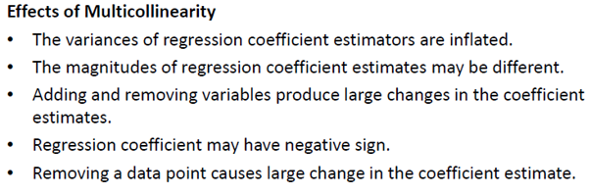
How to measure Multi-Collinearity:
Variance inflation factors (VIF) which assesses how much the variance of an estimated regression coefficient increases if your predictors are correlated. If no factors are correlated, the VIFs will all be 1. Use to describe how much Multicollinearity (correlation between predictors) exists in a regression analysis.

To avoid such situation, it is advisable to look for Variance Inflation Factor (VIF). For no multicollinearity, VIF should be ( VIF < 2). In case of high VIF, look for correlation table to find highly correlated variables and drop one of correlated ones.

VIF >5 -> MultiCollinearity

VIF =1 indicates no Collinearity

If there are 10 independent variables then there will be 10 VIF

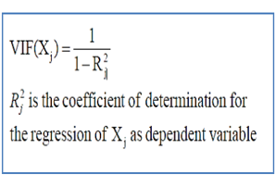

How to detect Multi-Collinearity:
- A regression coefficient is not significant even though, theoretically, that variable should be highly correlated with Y.
- When you add or delete an X variable, the regression coefficients change dramatically.
- You see a negative regression coefficient when your response should increase along with X.
- You see a positive regression coefficient when the response should decrease as X increases.
- Your X variables have high pairwise correlations.
- Coefficients of variables that are expected to be important, have large standard errors (small t values)
- The F ratio might be significant while none of the t value is significant
Multicollinearity: Detection & Removal
- Independent variables have significant correlation
- Check with pair-wise correlations
- Check with Variance Inflation factor (VIF)
- VIF>5 => Multicollinearity
- Why it is a problem?
  - It increases the standard error and affects the coefficients of independent variables
- If more than one variable has VIF > 5, one of them must be removed
- Remove one by one and choose the one which maximizes R²
VIF-Steps
- Proportion of variance of one predictor explained by all other predictors
- VIF_{j} = 1/(1-R²_{j})
- VIF = 1 indicates no collinearity
- Compute VIF for all predictors
- Drop the one with largest VIF above cut-off
- Re-compute and repeat until all VIFs are below cut-off (2,5,10)
- VIF=2.5 for a variable means R² of this variable with other predictors is 0.6 which is pretty high
- Remove highly correlated predictors from the model. If you have two or more factors with a high VIF, remove one from the model. Because they supply redundant information, removing one of the correlated factors usually doesn't drastically reduce the R-squared. Consider using stepwise regression, best subsets regression, or specialized knowledge of the data set to remove these variables. Select the model that has the highest R-squared value.
- Use Partial Least Squares Regression (PLS) or Principal Components Analysis, regression methods that cut the number of predictors to a smaller set of uncorrelated components.

Normal Distribution of error terms:

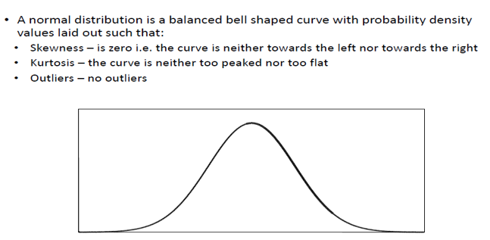

If the error terms are non- normally distributed, confidence intervals may become too wide or narrow. Once confidence interval becomes unstable, it leads to difficulty in estimating coefficients based on minimization of least squares. Presence of non – normal distribution suggests that there are a few unusual data points which must be studied closely to make a better model.

How to check: Following plots are used for examining these: Histogram, Box-Plot & Q-Q plots. You can also perform statistical tests of normality such as Kolmogorov-Smirnov test, Shapiro-Wilk test.

Heteroscedasticity

The p-values for the regression coefficients are based on satisfying the assumption of constant variance. Therefore, your p-values, and the associated decisions about the statistical significance of your predictors, can be incorrect if your residuals have non-constant variance.

Interpretation of Regression Plots
1. Residual vs Fitted Values
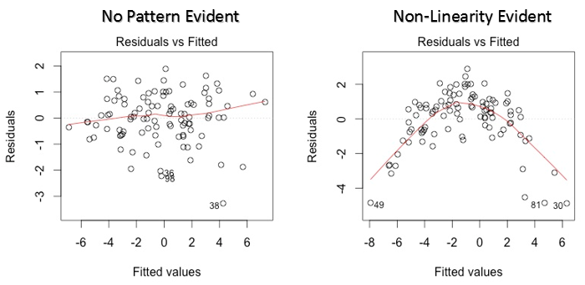
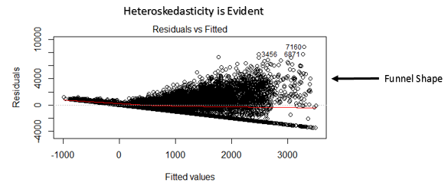
This scatter plot shows the distribution of residuals (errors) vs fitted values (predicted values). It is one of the most important plot which everyone must learn. It reveals various useful insights including outliers. The outliers in this plot are labeled by their observation number which make them easy to detect.
There are two major things which you should learn:
- If there exist any pattern (may be, a parabolic shape) in this plot, consider it as signs of non-linearity in the data. It means that the model doesn’t capture non-linear effects.
- If a funnel shape is evident in the plot, consider it as the signs of non constant variance i.e. Heteroskedasticity.
Solution: To overcome the issue of non-linearity, you can do a non linear transformation of predictors such as log (X), √X or X² transform the Dependent variable.
To overcome Heteroskedasticity, a possible way is to transform the response variable such as log(Y) or √Y. Also, you can use weighted least square method to tackle Heteroskedasticity.
2. Normal Q-Q Plot
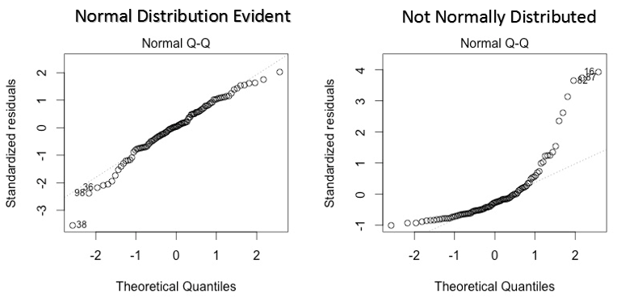
This q-q or quantile-quantile is a scatter plot which helps us validate the assumption of normal distribution in a data set. Using this plot we can infer if the data comes from a normal distribution. If yes, the plot would show fairly straight line. Absence of normality in the errors can be seen with deviation in the straight line.
If you are wondering what is a ‘quantile’, here’s a simple definition: Think of quantiles as points in your data below which a certain proportion of data falls. Quantile is often referred to as percentiles. For example: when we say the value of 50th percentile is 120, it means half of the data lies below 120.
Solution: If the errors are not normally distributed, Non – linear transformation of the variables (response or predictors) can bring improvement in the model.
3. Scale Location Plot
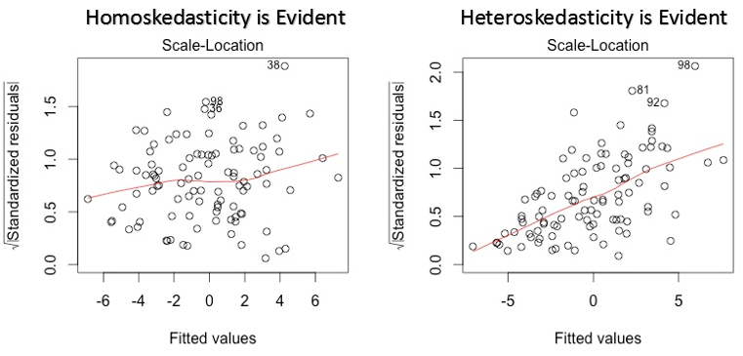
This plot is also used to detect Homoskedasticity (assumption of equal variance). It shows how the residual are spread along the range of predictors. It’s similar to residual vs fitted value plot except it uses standardized residual values. Ideally, there should be no discernible pattern in the plot. This would imply that errors are normally distributed. But, in case, if the plot shows any discernible pattern (probably a funnel shape), it would imply non-normal distribution of errors.
Solution: Follow the solution for heteroskedasticity given in plot 1.
4. Residuals vs Leverage Plot
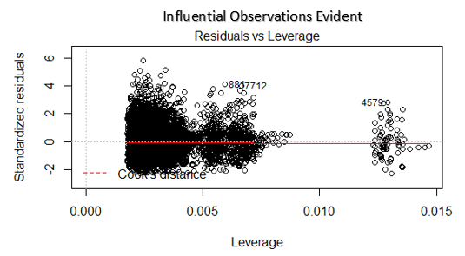
It is also known as Cook’s Distance plot. Cook’s distance attempts to identify the points which have more influence than other points. Such influential points tends to have a sizable impact of the regression line. In other words, adding or removing such points from the model can completely change the model statistics.
But, can these influential observations be treated as outliers? This question can only be answered after looking at the data. Therefore, in this plot, the large values marked by cook’s distance might require further investigation.
Solution: For influential observations which are nothing but outliers, if not many, you can remove those rows. Alternatively, you can scale down the outlier observation with maximum value in data or else treat those values as missing values.

you can plot the results using
> plot(lmfit)
This will produce a set of four plots:
- residuals versus fitted values,
- a Q-Q plot of standardized residuals,
- a scale-location plot (square roots of standardized residuals versus fitted values,
- a plot of residuals versus leverage that adds bands corresponding to Cook's distances of 0.5 and 1.

What about Non-Normality

Skew and Kurtosis
•Skew – much easier to deal with
•Kurtosis – less serious anyway
Transform data
•removes skew
•positive skew – log transform
•negative skew – square

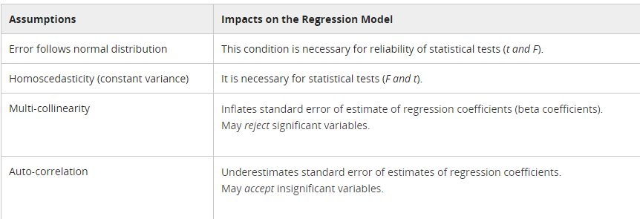

- An ideal model can’t have heteroscedasticity and multi-collinearity.
- OLS is the Best Linear Unbiased Estimate (BLUE).
- The interpretation of regression coefficients depends on the functional form of the relationship.

Various approaches used for model validation:
- R-square
- Standard error of estimate
- T-test

- The R-Square test is used to measure the Goodness of a model.
- The Standard Error test provides an estimate of standard deviation of regression errors.
- The ANOVA / F test checks the overall model significance.
- The T-test validates the relationship between dependent and individual independent variable.
MLR - Modelling Steps:
- Start with a belief or hypothesis.
- Estimate unknown model parameters.
- Assume that random error term follows normal distribution.
- Check for normality, heteroscadsticity and multi-collinearity.
- Evaluate and use model for prediction, estimation and other purposes

What should we do when we have a statistically insignificant variable in the MLR output?
One can say that, straight away remove them. But we have to be very careful because sometimes the variable may be statistically insignificant for reasons such as multi-collinearity. So, you have to go and ensure that the variable is not becoming statistically insignificant because of multi-collinearity.So, if we take care of those issues, then we can simply drop. But remember, when you drop, the regression coefficients will change.So, I had to go and re-run the model before I can actually use the model.

We cannot use ordinary least square to estimate parameters in logistic regression because many of the assumptions in multiple linear regressions are not valid in logistic regression. So we have to use a different technique.

